Hello😊

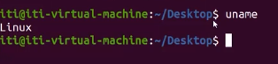 uname-> the kernel

 uname -n ->node name of my machine.

 -character --string

 uname -r -> release of kernel

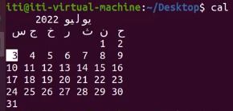 cal-> highlight my position on current month calender.

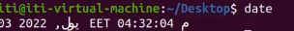 date -> returns my current date and time.

 man command -> manual

 anything between a [] can be written or not it is optional, . . . three dots means it can accept more than 1 option. To exit man press q

Options: change the behavior of the command.

Arguments: something that the command will use.

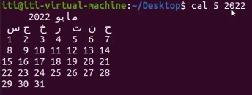 5 and 2022 are arguments.

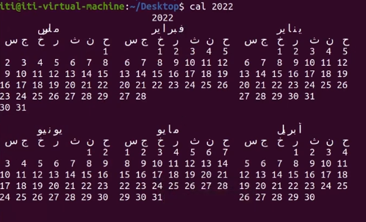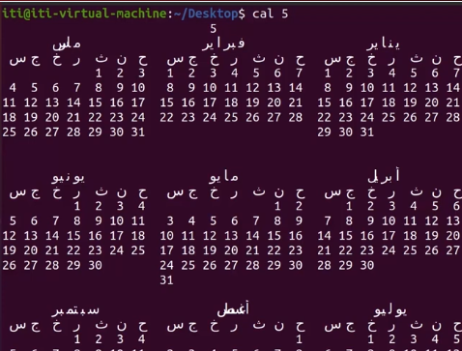 it returns year 5.



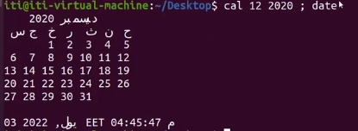 it executes command cal first then date. They don’t depend on each other, if one gives an error it will output error and if the other is correct, the correct will give output.

Ctrl+c to cancel a command

Ctrl+d to tell the computer that you finshed entering a input.

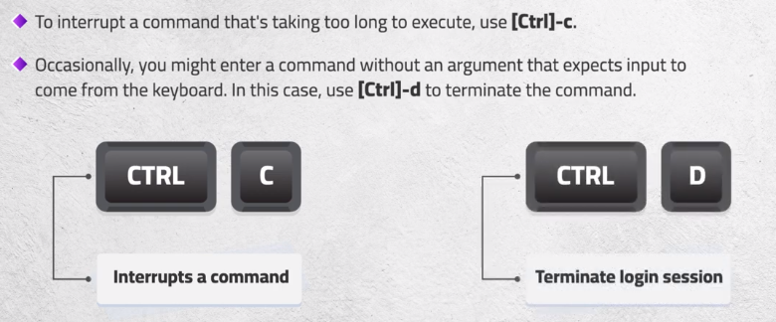

How to search in man? /searchword

n:next b:back

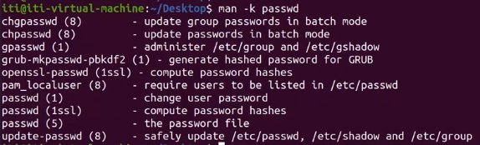

Man -k keyword -> searches for commands that has the keyword and give a short description for it.

Manual is divided into sections, when man command it opens the manual of command in first section it faces.

How to know each section is what about? mam man

 user commands are at section 1, file commands are at section 5,8: system administration commands(root)

 -s : section -> it opens passwd that is in section 5.

 opens all manuals of passwd in all sections.

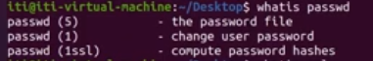 like man but man is the best

Some some commands has –help

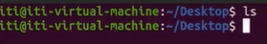 ls -> shows the files in a directory, here desktop is empty so it showed nothing

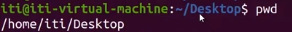 pwd -> print working directory

Ubuntu file system

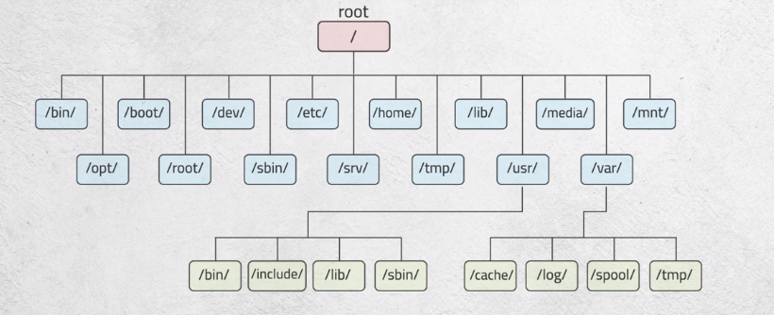

/dev/ : has files of all devices(keyboard, screan, etc)

/bin/ : has binary files of commands

/sbin/ : has binary files of commands that only the root can access

/etc/: has all configuration files

/home/: has files of home directories of all users.

/root/: has home directory of root

/var/: has directories that it’s size keep changing dramatically

 create a directory in your place named dir1

 when writing absolute path must write complete path from root. dir11 is the created folder.

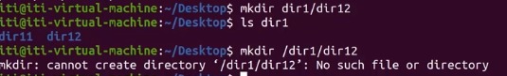 relative path: is going to create dir12 in dir1 that is in the desktop.

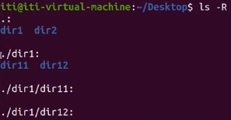 it returns tree from where I am.

.->is where I am now.



First is absolute, second is relative path.

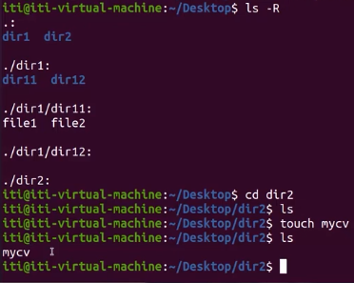



.. -> means go to my parent and then go to dir1 in it.

 it takes me to my home directory.

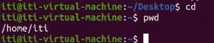 cd only: also takes me to my home.

 takes me to user1 home.

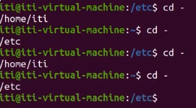takes me to the previous directory I was in.

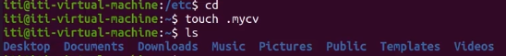 to hide a file rename it with dot before it.



Lists all files hidden or not.

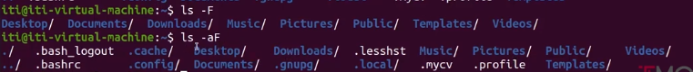

In order to know if this is directory or file.

Soft link: pointing to a file.

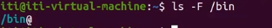 @ means it is a shortcut.

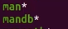 \* means it is executable file.

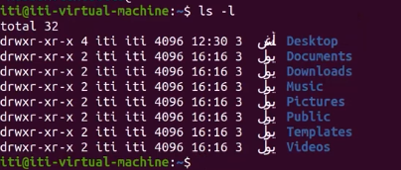 long format

First word: owner user of the file, second word: owner group then file size in bytes.

d->directory, - -> file, l -> soft link

first 3 permissions: user, second 3: group, last 3: others

…………..

When creating a user a group is created by the name of that user, but if when creating assigned to a group then no group creation happens.

-h : human readable size

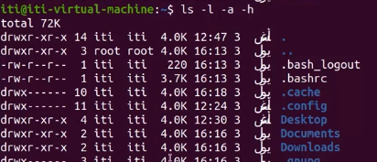

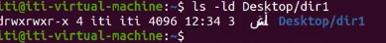 -d: gives info about the directory itself not the files in it like default.

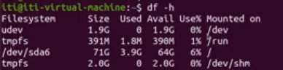shows every partion and it’s size.

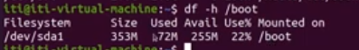 shows total size of boot as a partition.

 size of boot as a file. Because linux treats every directory as a file.

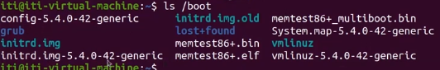 that file contains list of names of it’s contents.

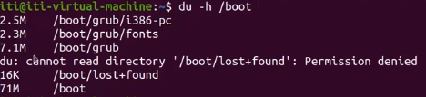 disk usage: shows size of each file and total size of the directory.

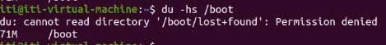returns the sum directly.

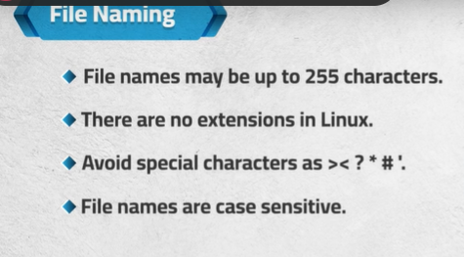

 shows the contents of the file passwd but gets to the end without showing the beginning.

 if my file is big

 enter (line by line) or space (the next screen) for more.

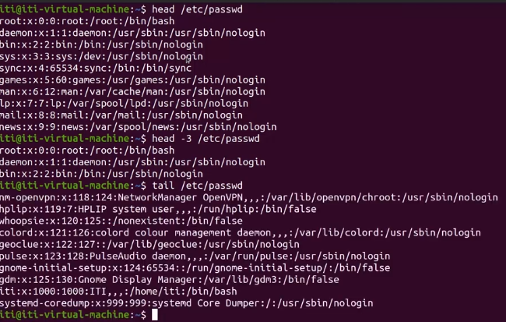 head: shows first 10 lines, -3: shows first 3, tail:last 10 lines

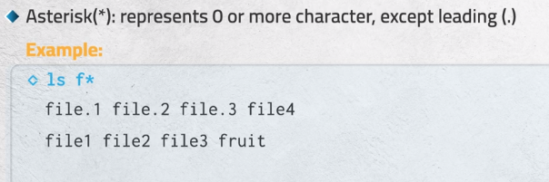

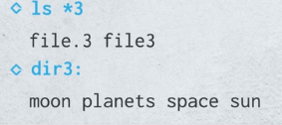

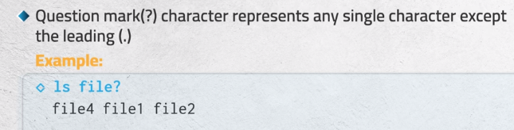

It substitutes first the question mark and if it didn’t find any it will search for “file?”

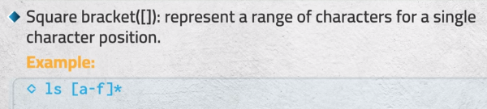

 match p or f then any number of characters.

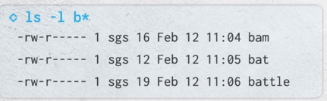 long listing for anything starts with b

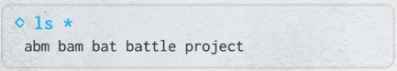 it doesn’t match hidden files that start with dot.

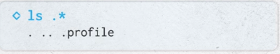 it shows all hidden

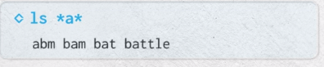 match anything that has “a” anywhere.

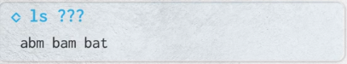match any file with 3 characters.

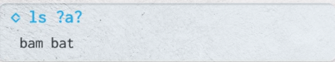 match 3 characters and 3rd must be “a”

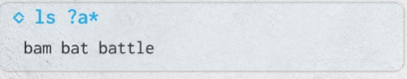 minimum 2 characters and second must be “a”

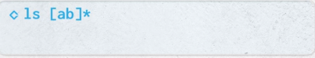match first to “a” or “b” then any number of characters.

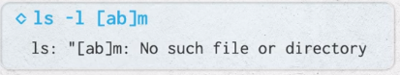 matches “am” or “bm” not “abm”

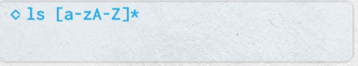 match first character to [a-b]or[A-B] and then anything. Anyfile start with number it won’t match

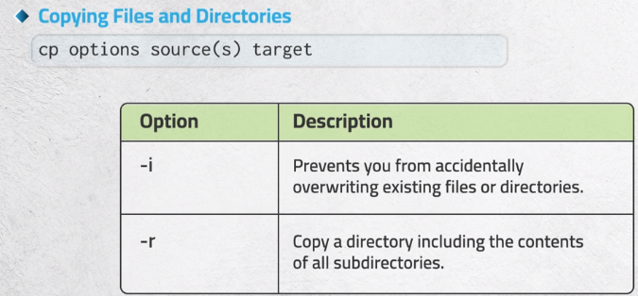

Cp group of files seperated with space and then directory

Copy a directory without -r raises and error.

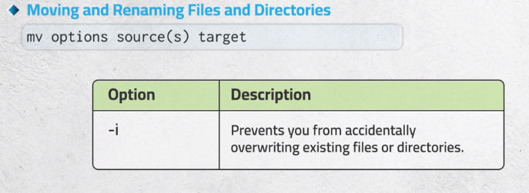

Can be used to rename with giving source same as destination

To mv (cut and paste) a directory no need for -r

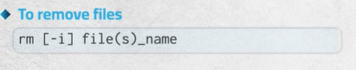

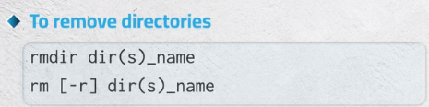 rmdir is when it is empty dir only.

Rm -r: to remove the directory and it’s contents

